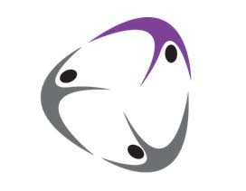
Park Wrekin College School of Gymnastics and Dance Ltd

13 July 2020

Dear Members

Following the Government announcement on Thursday, we are delighted that we will soon be able to welcome our members back to the gym after this long period of lockdown.

The plan is for our Elite Squad gymnasts to return on Saturday 25th July and for all other members training and classes to resume on Saturday 1st August. Preschool will return on Sunday 6th September.

We have a number of new procedures and some slight changes are necessary to our timetabling, details of those will follow later this week. In the meantime, if you have not already registered on our new system please do so as soon as possible by visiting:

https://parkwrekingymnastics.com/register/

Our coaches are looking forward to seeing you all again and having fun in the gym very soon!

Best wishes.

Christine Still
Head Coach

