Park Wrekin College School of Gymnastics and Dance Ltd

Prevention and Treatment of Hand Tears
WRITTEN WITH THE HELP & GUIDANCE OF THE BG/EIS TEAM

It is very important to care for the skin on your hands and wrists. As a gymnast, you have to take responsibility for this yourself (with a little help from your parents).

To maintain the quality of the skin you will need to keep the overall thickness consistent and the surface smooth. Failure to do this will result in uneven skin ridges, which will eventually tear.

Help Prevent Tears

Regularly shave the calluses down to a level that maintain a relatively thick yet consistent depth throughout the hand. There are many tools you can use to help achieve this e.g. files, pumice stones etc. It is best to do this after a hot shower or bath when the skin is softer.
Don’t overdo it! Always leave enough skin to keep the hands protected for training the next day. The aim is an even, consistent thickness of hard skin across the entire hand.

Treatment of Tears

- Carefully cut any hanging skin away with small sterilised scissors or nail clippers.
- Wash your hands with soap and hot water to remove any dirt and chalk. Apply antibacterial ‘Savlon’ spray or cream.
- Before you go to bed that evening, wash your hands with soap and hot water, re-apply the ‘Savlon’ and cover the wound with a small dressing.
- The following morning, wash your hands with soap and water but do not cover the tear from this point onwards, unless you are training. Allow the wound to dry out.
- Once the wound has dried out, it is important to keep it moisturised to prevent it from cracking.
- Whilst training, taping the hand in an upwards direction can protect the skin tear. (Tape around a finger and then down across the rip and around the wrist to secure – taping horizontally will come off easily!)
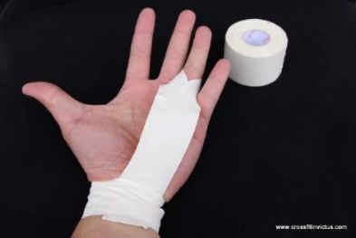

IMPORTANT INFORMATION FOR GYMNASTS & PARENTS

Even with every precaution, gymnasts’ hands and wrists can still sometimes tear. As with any injury, it is very important to speak with your coach if it is too painful to train on, alternative exercises can be found whilst the hands/wrists heal. Some of the club sections do not train on bars, if this is something you prefer then please speak with your Head of Department.

